**Applied Physics Assignment-1**

**Vectors**

1. A displacement vector in the *xy* plane is 4.3 m long and directed at angle of 40° in Fig.1. Determine (a) the *x* component and (b) the *y* component of the vector.

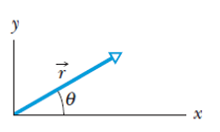 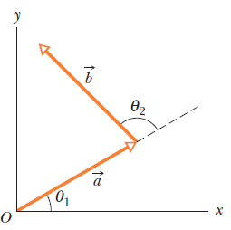

Fig-1 Fig-2

1. The two vectors ***a*** and ***b*** in Fig-2 have equal magnitudes of 10m and the angles are θ1= 35 $⁰$ and θ1= 102 $⁰.$ Find the (a) x and y components of their vector sum ***r*** (b) the magnitude of ***r*** and (c) the angle ***r*** makes with the positive direction of the x axis
2. Find the area of the parallelogram determined by the vectors: 2i - 13j + 5k and 5i + 2j - 4 k. What is the area of triangle determined by 2 vectors A=3i+4j-k and B=-3i+7j-4k ?
3. The *x* component of vector ***A*** is 25.0 m and the *y* component is 40.0 m. (a) What is the magnitude of ***A*** (b) What is the angle between the direction of and the positive direction of *x*?
4. A ship sets out to sail to a point 120 km due north. An unexpected storm blows the ship to a point 100 km due east of its starting point. (a) How far and (b) in what direction must it now sail to reach its original destination?
5. Three vectors ***a , b*** and ***c*** each have a magnitude of 50 m and lie in an xy plane. Their directions relative to the positive direction of the x axis are 30°, 195°, and 315°, respectively. What are (i) the magnitude and the angle of the vector ***a+b+c*** , and

(ii) the magnitude and the angle of ***a-b+c***? What are the (iii) magnitude and angle of a fourth vector ***d*** such that ***(a+b ) – (c+d) = 0*** ?

1. Find the angle between the vector A= 2i -3j+5k and the x, y,and z axes, respectively.
2. Calculate the angle between “r” and the positive z-axis. (c) Find the angle between “a” and “b”. where a = 5i +4j -6k , b= -2i +2j+3k and c = 4i+3j+2k , r = a+b+c.
3. Vector A has a magnitude of 6 units, vector B has a magnitude of 7 units, and A.B has a value of 14. What is the angle between the direction of A and B?
4. Determine the value of “X” such that **A** = 4**i** + X**j** + 2**k** and **B** = 4**i** - 8j - 2**k** are perpendicular.